English Flypped News
Stay Informed Daily
Mirjam Nilsson  Flypped News: Your Smart, Simple and Fun English Magazine Online  The latest updates  In today’s busy world, staying updated should not feel difficult—especially for young readers. That is why Flypped News has become one of the most loved digital magazine India platforms. It brings easy-to-read stories, exciting updates, and helpful tips for everyone. Whether you love Bollywood, sports, travel, health, or fashion—flypped magazine gives you everything in one place. |  |  | 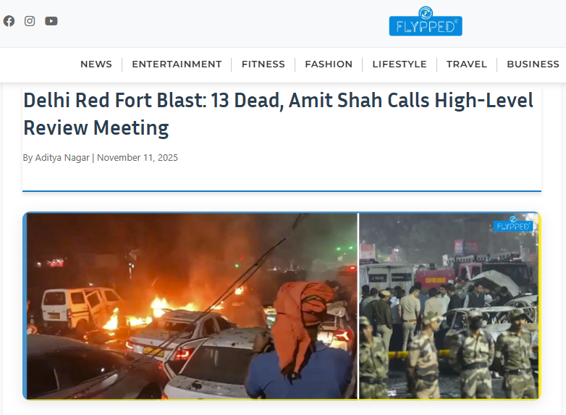
 |  |  | Delhi Red Fort Blast: 13 Dead, Amit Shah Calls High-Level Review Meeting
Why Flypped News Portal Is the Best English Magazine Online
The Flypped News Portal is designed like a colorful flypped e-magazine where even children can understand the content without any confusion. It keeps you informed with:

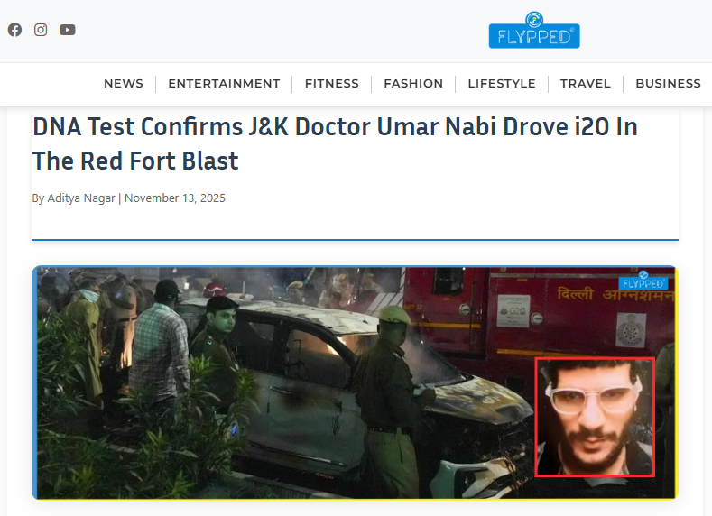 |  |  | - Latest news updates India  - Exciting stories from India today online magazine English readers love | - Simple explanations of national and global events  - Today news updates
DNA Test Confirms J&K Doctor Umar Nabi Drove i20 In The Red Fort Blast

If you want news updates today in clean and clear English, this is the perfect place.

Bollywood Updates by Flypped — Fashion, Films, and Fun
Latest Bollywood Fashion Updates
From glamorous gowns to trendy street looks, Flypped covers:
Everyone loves reading about stars, and Bollywood updates by Flypped bring the latest gossip, movie releases, and stylish trends.

- Bollywood fashion trends
- The fashion icon of Bollywood
- The charming fashion queen of Bollywood
- The stylish fashion king of Bollywood
- Fashion tips for men and fashion tips for women
- Simple fashion tips anyone can follow
- Smart fashion tips and tricks
- Professional fashion marketing tips and fashion designing tips

If you love style, Flypped will keep your fashion sense updated and fresh.
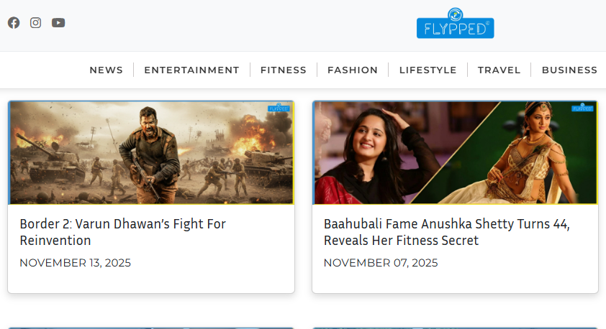
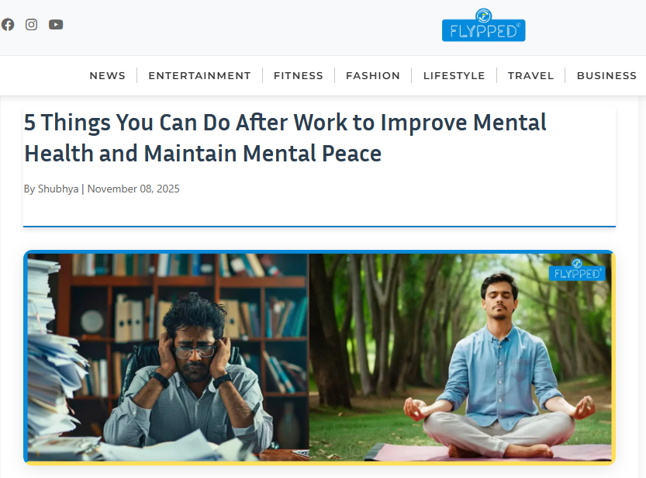 |  |  | Health and Lifestyle Magazine Flypped – Stay Fit and Happy  The Health and lifestyle magazine Flypped section teaches you how to stay strong, active, and full of energy.  Top Health Tips and Fitness Advice  Flypped shares:  - Health and fitness tips  - Best fitness tips for everyday life  - Top 10 health tips  - Top 10 health and fitness tips  - Best health tips trusted by experts  - What is a fitness tracker, and how it helps  - How kids and adults can stay healthy at home  This makes Flypped one of the best wellness and fitness platforms for families.
5 Things You Can Do After Work to Improve Mental Health and Maintain Mental Peace
Tonnie Thomsen

Travel Guide From Flypped – Explore the World Easily
Do you dream of traveling but don’t know where to start? The Travel guide from Flypped is easy, simple, and fun to read.
Best Travel Tips and Tricks  Here you will find:  - How to travel like a pro  - A simple travel guide for beginners  - Useful travel tips and tricks  - The best vacation tips for families | - Easy tips for travelling safely  - The top 10 travel tips every traveler must know  - Friendly travel tips and advice  - The world’s best travel tips explained in simple words  - Smart travel recommendations  - The best vacation tips for families
 |  |  | 5 Things You Can Do After Work to Improve Mental Health and Maintain Mental Peace


Travel Guide From Flypped Explore the World Easily
In a world full of complicated information, Flypped News shines as a simple, smart, and helpful digital magazine India readers trust. From Bollywood updates to Cricket News, from health tips to travel guides, Flypped brings everything in a child-friendly and exciting way.
If you want a fresh, clear, and attractive online reading experience, the Flypped News Portal is the best place to start every day.

